Home Work 1 (2007-09-10)
Submission deadline: 2007-09-17

Question 2:
i). Give an account of advantages and disadvantages of inheritance and composition.
Inheritance is a powerful way to achieve code reuse.
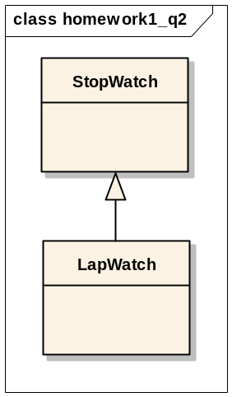
Class LapWatch inherits the definitions in the StopWatch definition. All the definitions found in the StopWatch class are included in the definition of the LapWatch. In such way, we think of the definitions added by the LapWatch class as extending the definition of the StopWatch.

LapWatch is regarded as a subtype or subclass of StopWatch, we can able to achieve polymorphism.
Conside the following code:

class StopWatch {
public void start() {
System.out.println("StopWatch");
}
}

class LapWatch extends StopWatch {
public void start() {
System.out.println("LapWatch");
}
}

public class Test {
public static void main(String[] args) {
StopWatch stop = new StopWatch();
stop.start(); // results in "StopWatch"
StopWatch lap = new LapWatch();
lap.start(); // results in "LapWatch"
}
}

Though, object stop and lap has the same type:, StopWatch, at compile time, but at run time, the virtual machine can determine the actual type/subtype, and calls the appropriate type-specific behavior. It means that if class B inherits from class A, it doesn’t have to inherit everything about class A; it can do some of the things that class A does differently.

However inheritance breaks encapsulation, in other words, a subclass depends on the implementation details of its superclass for its proper function. The implementation in superclass may change from time to time, and in that case, the subclass may break, even though its code remains untouched.

Regarding to composition, contained objects are accessed by the containing class solely through their interfaces, the internal details of contained objects are not visible, and the composition can be defined dynamically at run-time through objects acquiring references to other objects of the same type.
However, the resulting systems tend to have more objects, and the interfaces must be carefully defined in order to use many different objects as composition blocks.

ii).Give an example of when inheritance is better and when composition is better
Composition is used in such way that you want the features of a ready-made class inside your class, which means you embedded an object and use it to implement functionally in your new class. By making embed objects private, the user of your new class sees the interface you’ve defined, instead of the interface from embedded object.

On the other hand, inheritance utilizes an existing class and makes a particular version of it. You take a general-purpose class and specialize it for certain need.

In all, inheritance stands for the “is a” relationship, and composition presents the “has a” counterpart.

Question 4:
Draw a class diagram for the case of our course. We assume that there are at least the following classes: Person, Student, Instructor and Assistant (you can add as many additional classes as you would like). You should draw associations between them, possible attributes and operations.

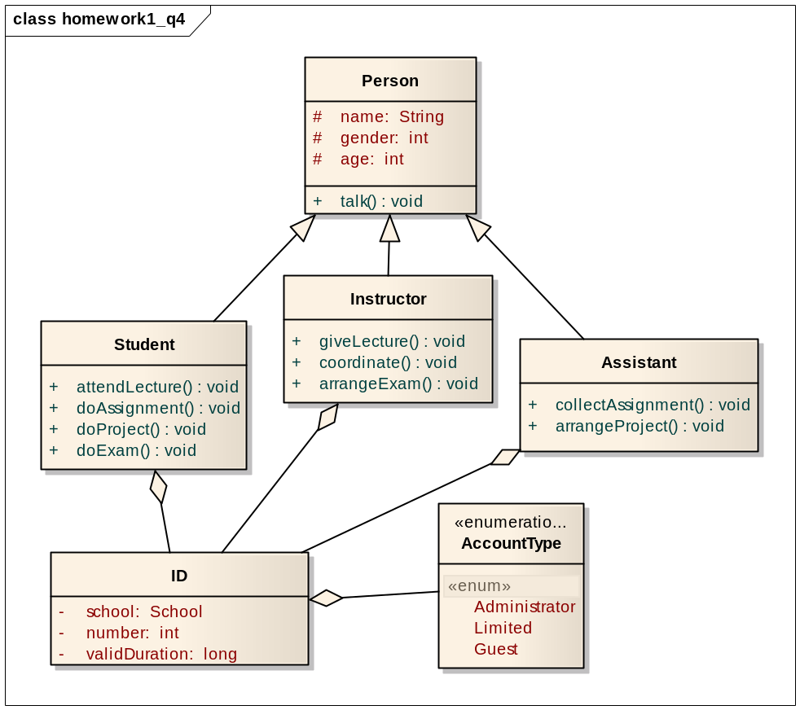

Question 6:
Draw a class diagram for a part of a Car Sharing System, based on a personal interview transcript. Identify any aggregation associations.
Andres: Just remind me, what kind of things do you need to know about the start and the destination of each journey?
Mihhail: We'd want to know the building name and number, the apartment number, the street, town or city, county and postal code or zip code. We'd also want to hold similar information for the home adress of the sharer as well.
Andres: OK. Didn't you say that the journey start and destination address will be used to match up possible shared journeys?
Mihhail: Yes -interesting point that. I'm not quite sure how you'll do this. We want to be able to establish whether two addresses are close enough to each other to be able to consider them a match for a shared journey. For example, two people may want to get from a start destination on adjacent corners of two different blocks to destination addresses in different floors of the same building. A person looking at the addresses would know that the addresses are similar enough to be a match, but in terms of just text of the addresses, they look completely different.

